**STORMY TABLE FANS:**

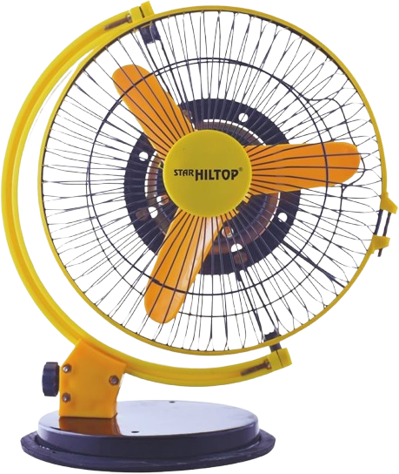

**Price: 9,000.00**

The Stormy Table Fan is a powerful and compact ventilation solution, designed to provide intense airflow and cooling relief in a variety of settings. With its robust motor and aerodynamic design, this fan delivers a strong and gusty breeze, effectively cooling large areas and improving air circulation. Its compact size, adjustable speed settings, and durable construction make it an ideal choice for homes, offices, and outdoor spaces, providing a refreshing and invigorating cooling experience.

**Key features of stormy table include:**

* **High Airflow** – Delivers strong and powerful airflow for efficient cooling.
* **Durable Build** – Made with sturdy materials for long-lasting performance.
* **Adjustable Speed** – Multiple speed settings for customized air circulation.
* **Compact Design** – Space-saving and easy to place on tables or desks.
* **Quiet Operation** – Designed to minimize noise, making it suitable for quiet environments.
* **Adjustable Tilt** – Allows for directional airflow to target specific areas.
* **Energy Efficient** – Consumes minimal power for effective cooling while reducing costs.